United Presbyterian Church Worship Guide
March 14, 2021 Fourth Sunday in Lent

WELCOME AND ANNOUNCEMENTS The Reverend John Napoli
PRELUDE Sarabande from BWV 808 Benjamin Watkins, piano

Call to Worship Elder Bob Hammel, liturgist
Liturgist: Worship our God, companion and guide.
People: God is close to us in terrible times and in wonderful times.
Liturgist: God gives us all we need; God leads us to places that restore our souls.
People: Let us worship this God whose constancy we can count on.

PASSING OF THE PEACE
Liturgist: The peace of Christ be with you.
People: And also with you.
Liturgist: Let us share the peace with one another.

PRAYER OF CONFESSION (in unison with Liturgist)
God of light and love, we humble ourselves this day to ask forgiveness for the wrongs we have done. We have lived in darkness rather than seeing the light of your love for us and all your children. We have failed to live out your compassion and light to others. Our eyes have been closed. Our spiritual blindness has caused hurt and degradation; it has caused dishonesty and arrogance. In our moments of doubt, give us courage to believe in you. When new ideas present themselves to us, open our eyes to new vision, new understanding, and boldness in living into those ideas. Save us and help us, through Christ, the good Lord we pray. Amen.

WORDS OF ASSURANCE (Liturgist)
Hear the good news! Who is in a position to condemn? Only Christ, and Christ died for us, Christ rose for us, Christ reigns in power for us, Christ prays for us.
Anyone who is in Christ is a new creation. The old life has gone; a new life has begun. Know that you are forgiven and be at peace. Amen.
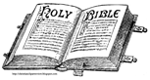

The Gospel Lesson Mark 11: 20-25
Liturgist: The word of the Lord
People: Thanks be to God

MUSIC MEDITATION We Walk by Faith and Not By Sight Benjamin Watkins, piano


SERMON
Fig Trees and Mountains
Reverend John Napoli

AFFIRMATION OF FAITH The Apostle’s Creed (traditional)
I Believe in God the Father Almighty, Maker of heaven and earth, And in Jesus Christ his only Son our Lord; who was conceived by the Holy Ghost, born of the Virgin Mary, suffered under Pontius Pilate, was crucified, dead, and buried; he descended into hell; the third day he rose again from the dead; he ascended into heaven, and sitteth on the right hand of God the Father Almighty; from thence he shall come to judge the quick and the dead. I believe in the Holy Ghost; the holy catholic Church; the communion of saints; the forgiveness of sins; the resurrection of the body; and the life everlasting. Amen.

PRAYERS OF THE PEOPLE AND THE LORD’S PRAYER
Our Father who art in heaven, hallowed be thy name. Thy kingdom come, thy will be done, on earth as it is in heaven. Give us this day our daily bread; and forgive us our debts, as we forgive our debtors; and lead us not into temptation, but deliver us from evil. For thine is the kingdom and the power and the glory, forever. Amen.

CALL TO OFFERING Reverend John Napoli

CHARGE AND BENEDICTION Reverend John Napoli

THE POSTLUDE My Shepherd Will Supply My Need Benjamin Watkins, organ

UPC Prayer List - Email requests to: pastor.upcbloomington@gmail.com.
Fr the health of Sue Lorimer and to celebrate 65 years of marriage for Bob & Sue
Evelyn Rose Troy Hill Shea Henry Judie Iverson Billy & Mary Lou Rhoades
Ceci Schuman Alexander de Vos van Wael Nora vander Heijden
His Eyes Mission in Honduras Nyaka AIDS Orphans Project in Uganda
Our elementary, high school, college and grad students as they face these difficult times
Sheriff, Deputies, Police, Doctors, RNs, LPNs, CNAs, Med Techs and EMTs
Our military men and women around the world
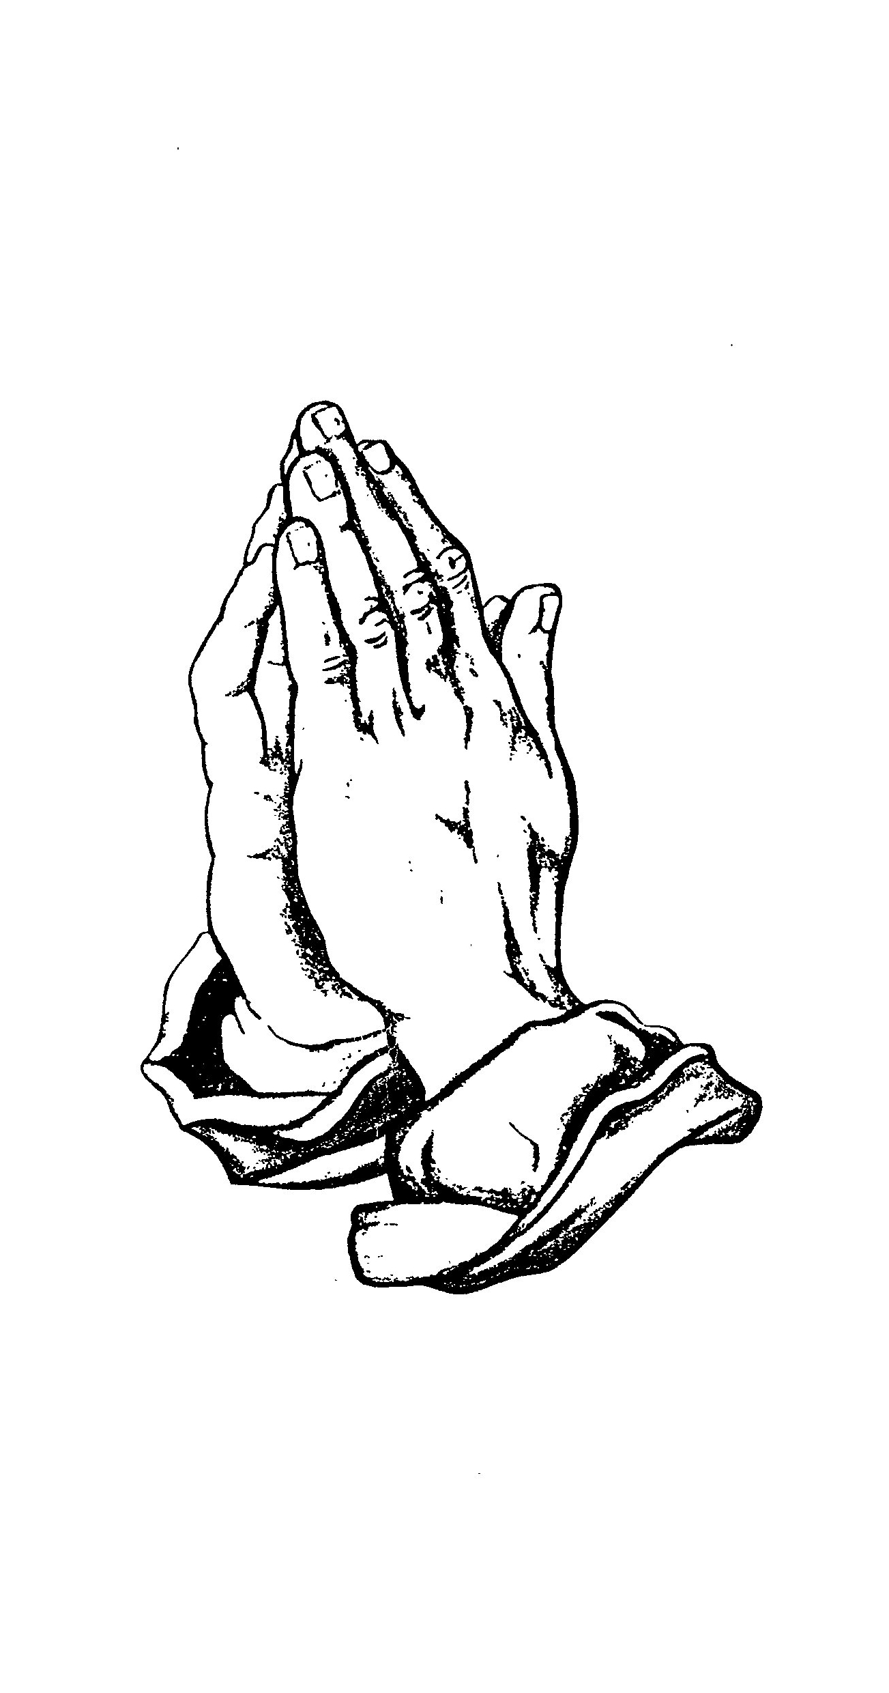
POV Committees. Much of the work of the Presbytery of Ohio Valley happens in our committees and commissions: the Presbytery Council, Board of Trustees, Committee on Ministry, Committee on Preparation for Ministry, Personnel Committee, Nominating Committee, Stewardship Committee, Evangelism and Congregational Witness Committee, Congregational Mission and Vitality Committee, and the Permanent Judicial Commission. With pandemic restrictions beginning in March of 2020, these committees needed to shift the way they met and worked. We are grateful for all who have agreed to serve.

