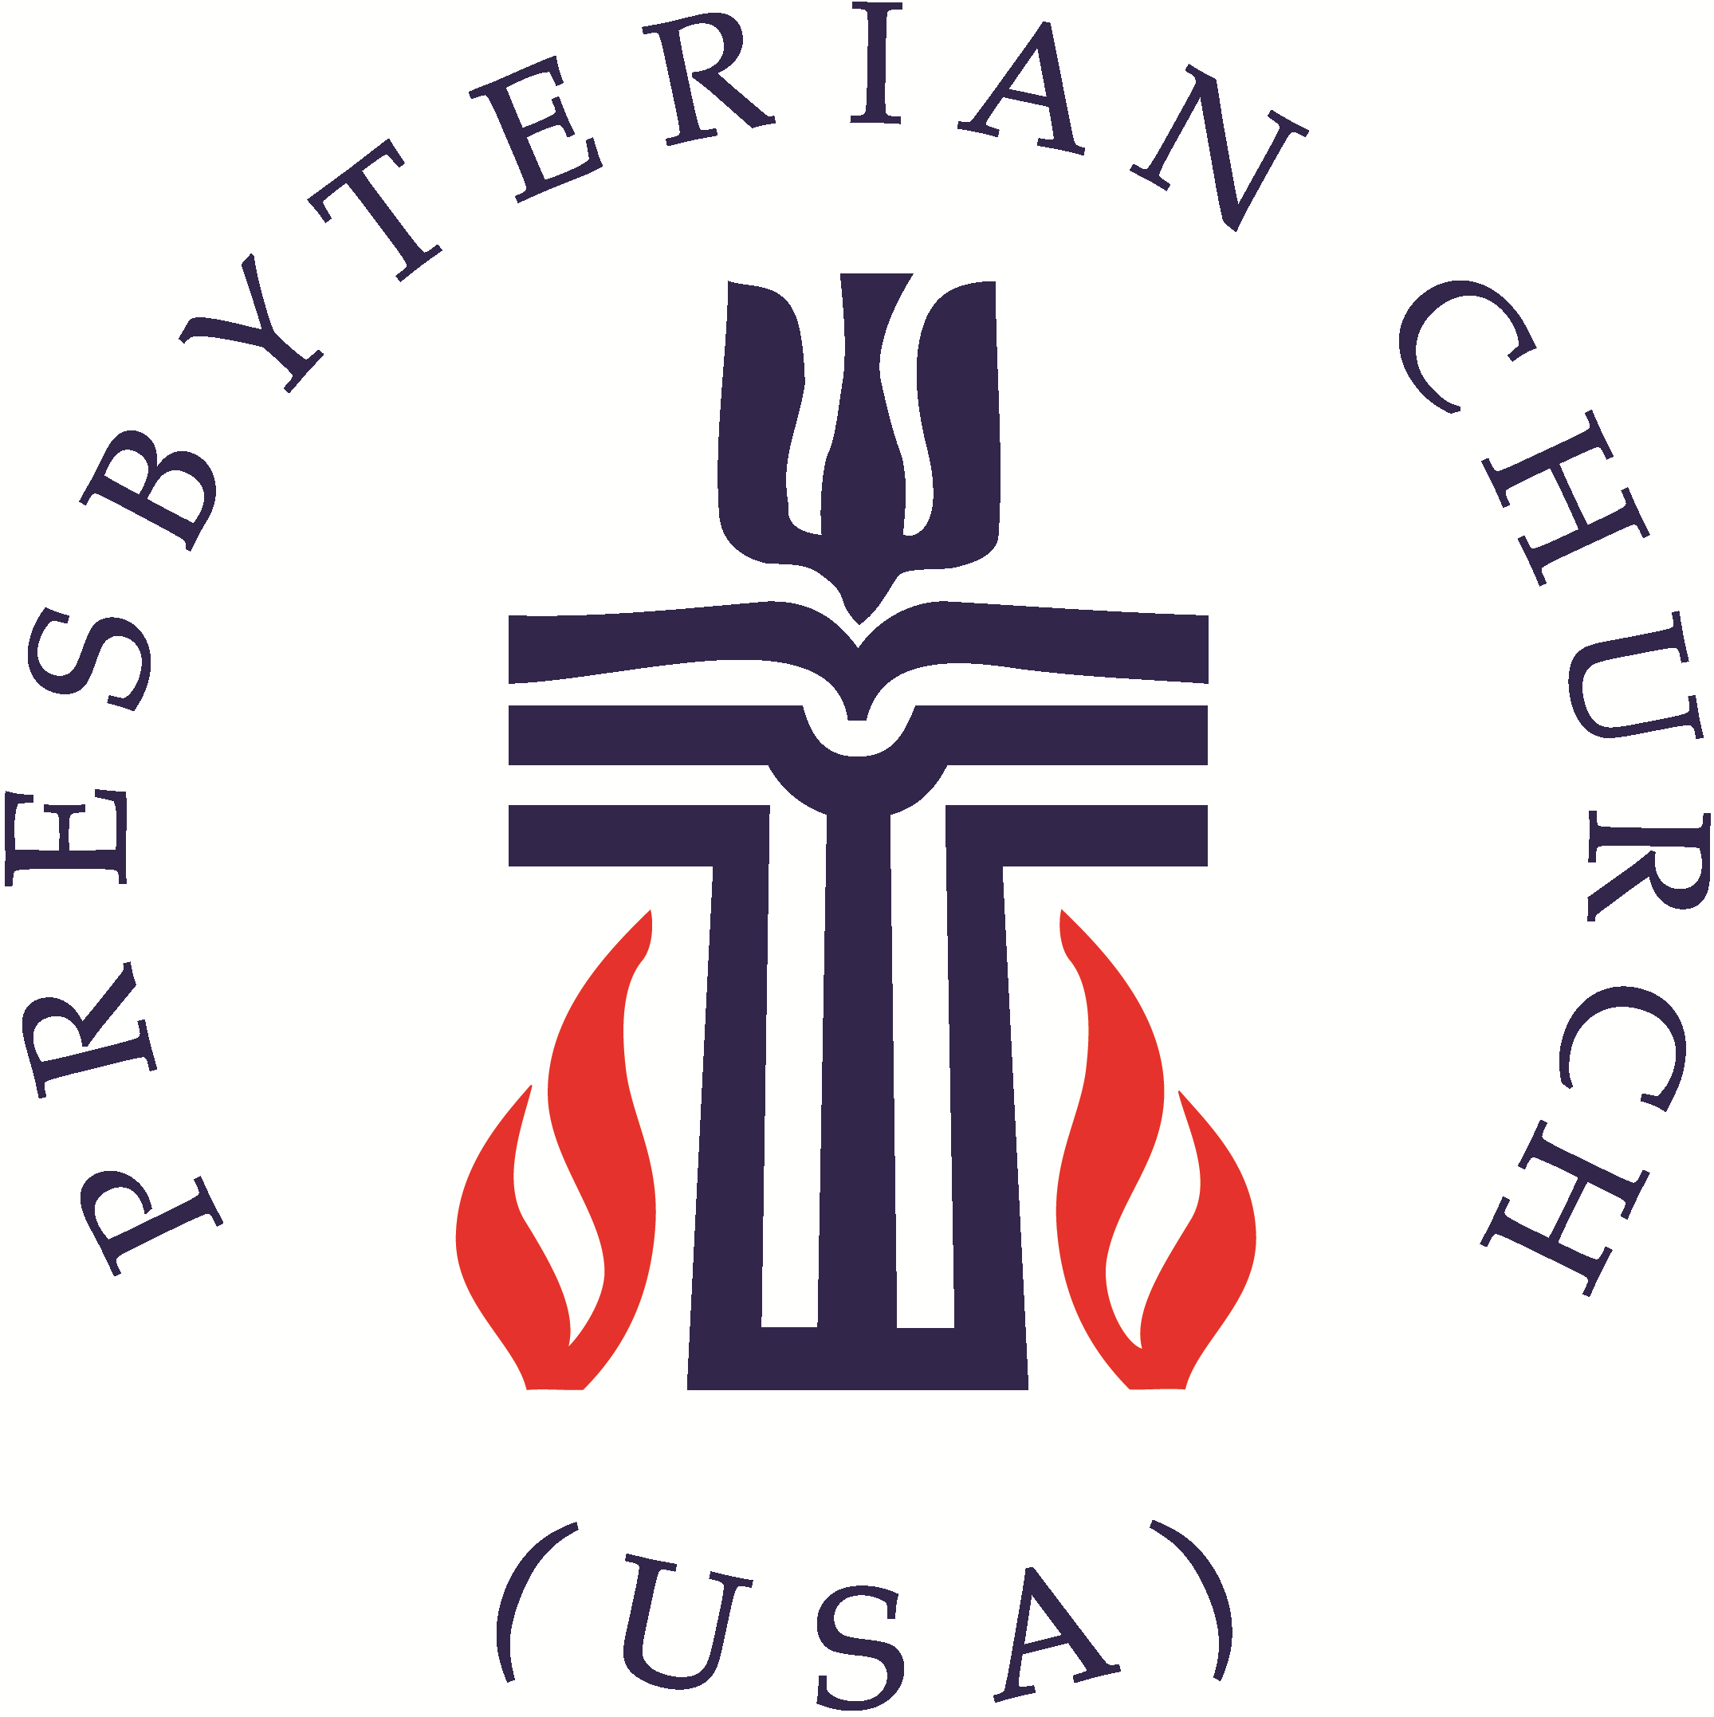
United Presbyterian Church Worship Guide
May 30, 2021 – Trinity Sunday

WELCOME AND ANNOUNCEMENTS Reverend John Napoli
PRELUDE All Creatures of Our God and King Benjamin Watkins, piano

Call to Worship Elder Bob Hammel, liturgist
Liturgist: Praise God for the wonders of creation: the moon and stars, the birds of the air, and the beasts of the field.
People: O God, our God, how majestic is your name.
Liturgist: You have created all things and proclaim all things good. You have created each one of us and proclaim that we are good.
People: O God, our God, how majestic is your name.
Liturgist: Be present with us now in all your wonderful ways!

PASSING OF THE PEACE
Liturgist: The peace of Christ be with you.
People: And also with you.
Liturgist: Let us share the peace with one another.

PRAYER OF CONFESSION (in unison with Liturgist)
God of grace, love, and communion, we confess that we have failed to love you with all our heart, soul, and mind; and to love our neighbor as ourselves. We ignore your commandments, stray from your way, and follow other gods. Have mercy on us. Forgive our sin and raise us to new life that we may serve you faithfully and give honor to your holy name. In the name of Jesus the Christ we pray. Amen.

WORDS OF ASSURANCE (Liturgist)
Hear the good news! The saying is sure and worthy of full acceptance, that Christ Jesus came into the world to save sinners. He himself bore our sins in his body on the cross, that we might be dead to sin, and alive to all that is good. I declare to you in the name of Jesus Christ, you are forgiven. Amen.

The First New Testament Lesson Acts 2: 14 – 28
The Second New Testament Lesson Acts 2: 29 - 41
Liturgist: The word of the Lord
People: Thanks be to God


MUSIC MEDITATION I Danced In the Morning Benjamin Watkins, piano
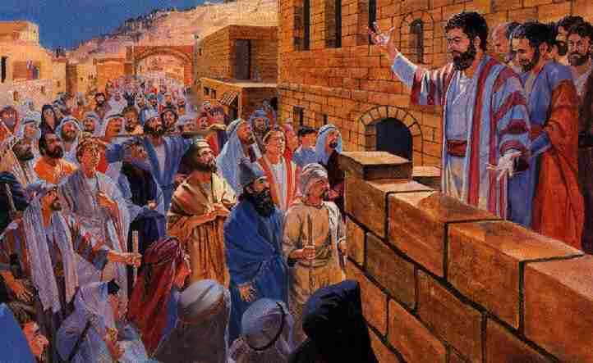
SERMON
Peter’s Message
Reverend John Napoli
(Segment four of a 23 sermon series titled The Acts of the Apostles)

AFFIRMATION OF FAITH The Apostle’s Creed (traditional)
I Believe in God the Father Almighty, Maker of heaven and earth, And in Jesus Christ his only Son our Lord; who was conceived by the Holy Ghost, born of the Virgin Mary, suffered under Pontius Pilate, was crucified, dead, and buried; he descended into hell; the third day he rose again from the dead; he ascended into heaven, and sitteth on the right hand of God the Father Almighty; from thence he shall come to judge the quick and the dead. I believe in the Holy Ghost; the holy catholic Church; the communion of saints; the forgiveness of sins; the resurrection of the body; and the life everlasting. Amen.

PRAYERS OF THE PEOPLE AND THE LORD’S PRAYER
Our Father who art in heaven, hallowed be thy name. Thy kingdom come, thy will be done, on earth as it is in heaven. Give us this day our daily bread; and forgive us our debts, as we forgive our debtors; and lead us not into temptation, but deliver us from evil. For thine is the kingdom and the power and the glory, forever. Amen.

CALL TO OFFERING Reverend John Napoli
The Pentecost Offering was received last Sunday. A basket and Pentecost envelopes are in the Narthex again today. Pentecost offerings may also be mailed to the church office.
CHARGE AND BENEDICTION Reverend John Napoli
POSTLUDE Amazing Grace Benjamin Watkins, organ

UPC Prayer List - Email requests to: pastor.upcbloomington@gmail.com.
The family of the Rev. Felipe Martinez (First, Columbus) as they mourn the death of his mother, Olga D. González de Martínez last Saturday at the age of ninety-five
The family of Billy Rhoades and his loving widow Mary Lou
Evelyn Rose Shea Henry Troy Hill Judie Iverson Sue Lorimer Ceci Schuman
Alexander de Vos van Wael Nora vander Heijden
His Eyes Mission in Honduras Nyaka AIDS Orphans Project in Uganda
The Center for Congregations is funded by the Lilly Endowment as a gift to Indiana churches to strengthen congregations. It offers no-cost consulting, education and grants. The digital resource (thecrg.org) is continuously updated. Posts address Mental Health, Post-Pandemic Prep and Anti-racism. Offices are in Evansville, Indianapolis or Seymour. Minister at large Wendy McCormick is in Evansville serving southwest Indiana and statewide efforts. Please pray as the Center seeks to be responsive to rural churches and churches of color.

