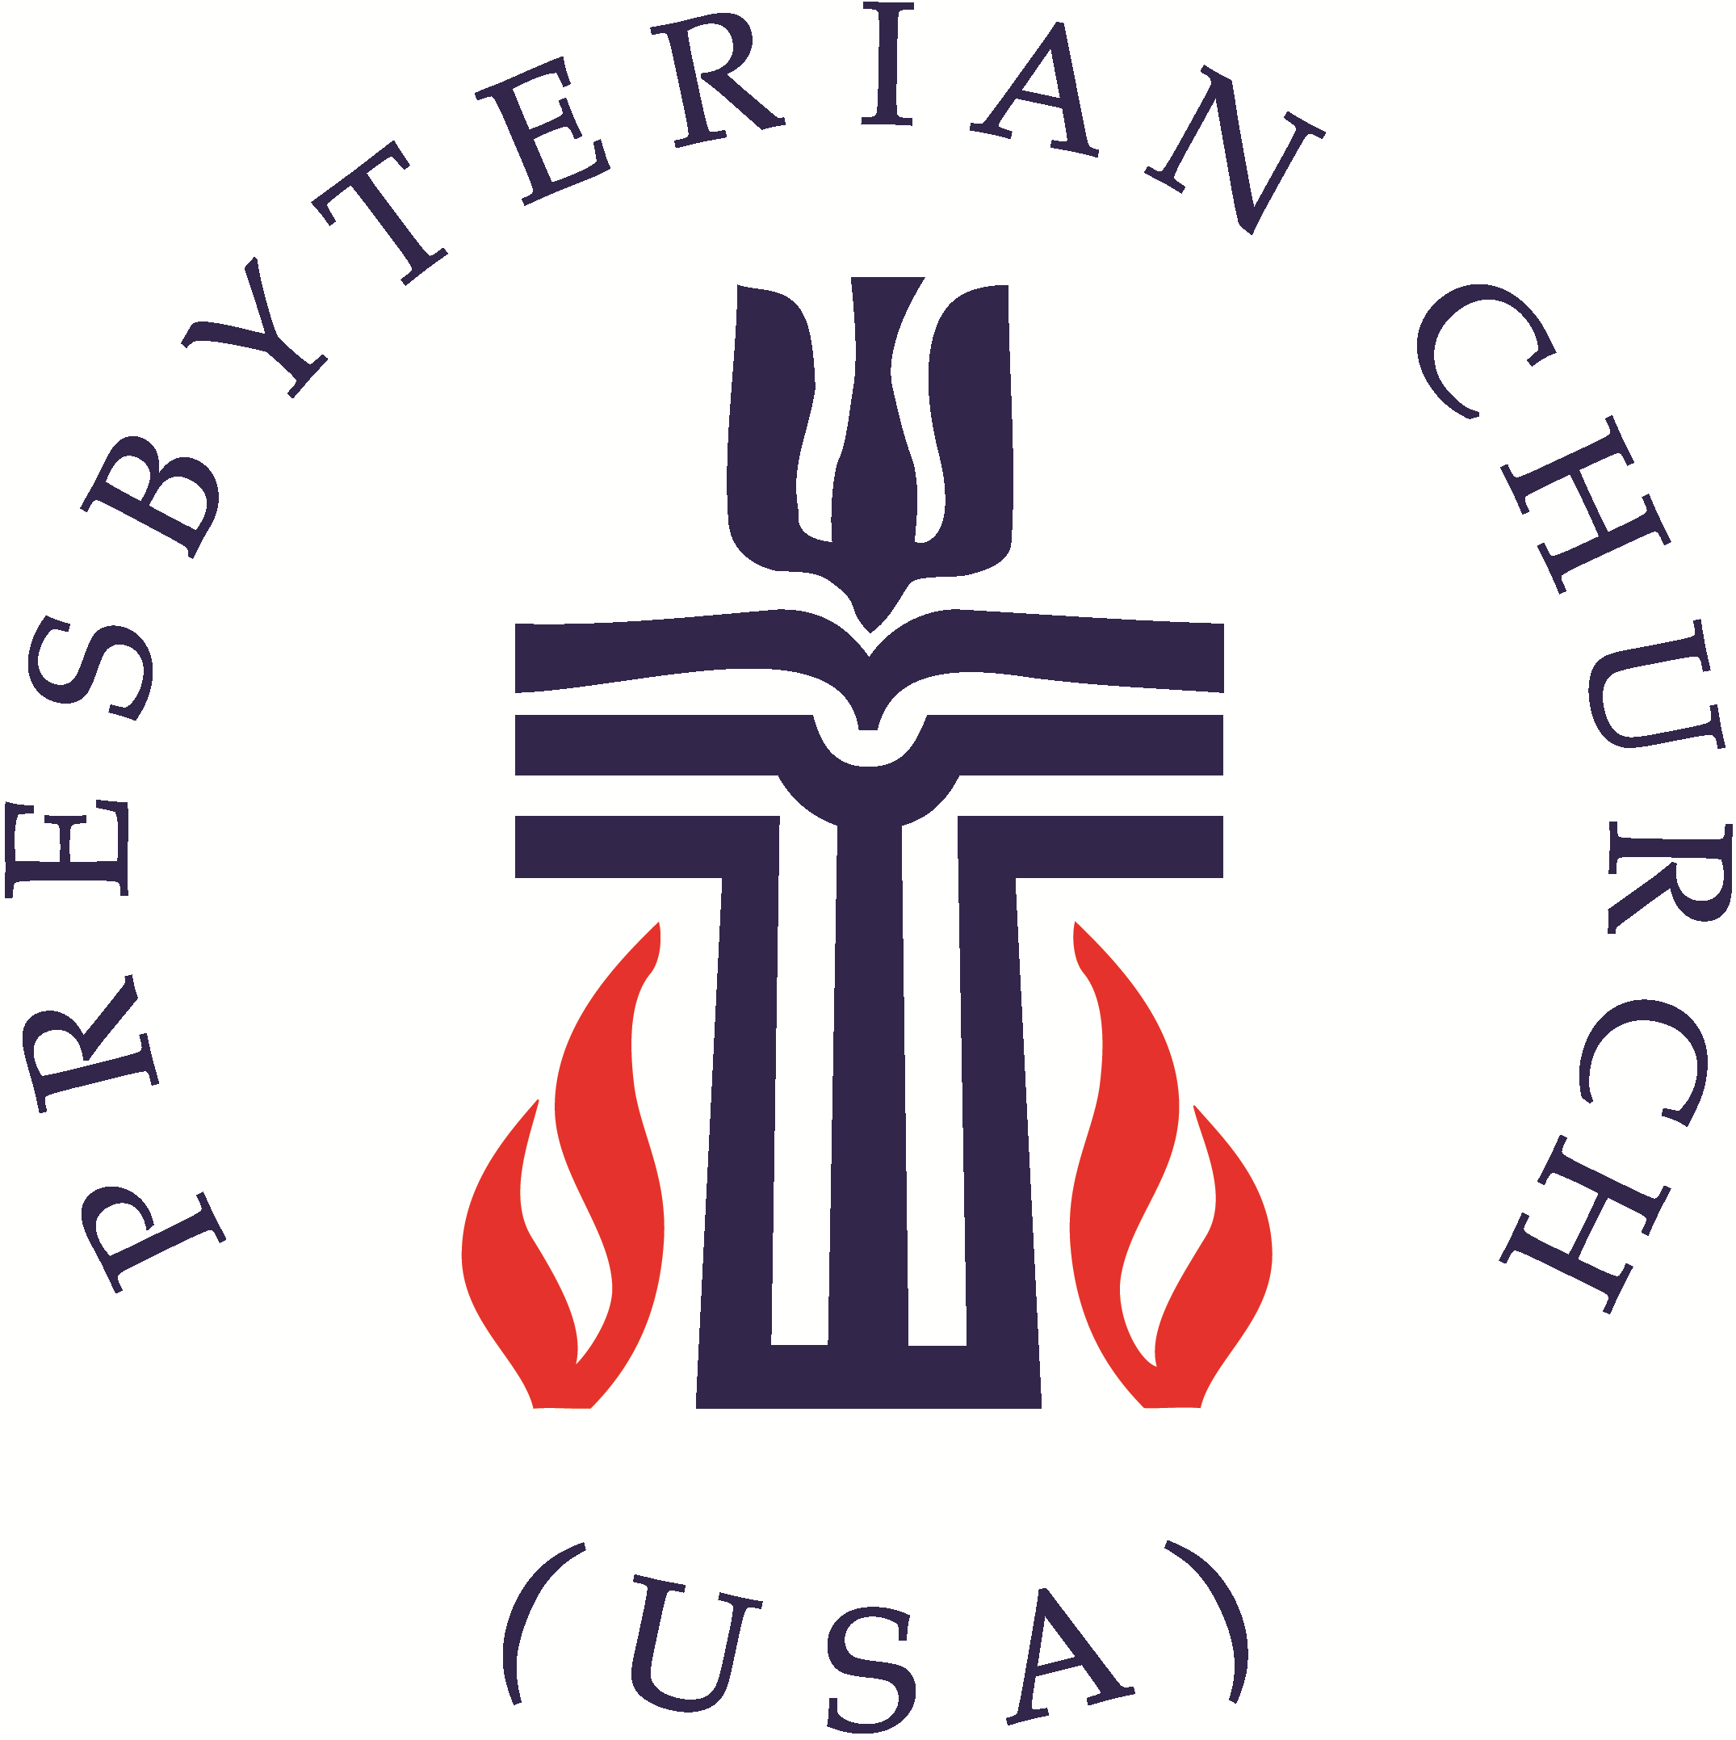
United Presbyterian Church Worship Guide
June 6, 2021 – Second Sunday after Pentecost

WELCOME AND ANNOUNCEMENTS Elder Bob Hammel
PRELUDE How Great Thou Art Benjamin Watkins, piano

Call to Worship Elder Darian McBride, liturgist
Liturgist: Call on the name of God.
People: God hears our voice and listens to our longings.
Liturgist: Even when times are hard, there is hope in our God.
People: Let us worship the God who inspires and calls us to live creatively.

PASSING OF THE PEACE
Liturgist: The peace of Christ be with you.
People: And also with you.
Liturgist: Let us share the peace with one another.

PRAYER OF CONFESSION (in unison with Liturgist)
Eternal God, forgive us for failing to go and proclaim the gospel to all your children. Like the disciples, we are afraid of being rejected; we are busy; we are scared. You know all our excuses. You call us to travel lightly yet we allow ourselves to become burdened by so much. You call us to proclaim the good news, cure the sick, offer new life to those who are lost. Forgive us our failure to be obedient to your call. Forgive us and send us on our way. In the name of the Risen Christ we pray. Amen.

WORDS OF ASSURANCE (Liturgist)
Hear the good news of the gospel! You are no longer strangers and aliens, but members together of the household of God, built upon the foundation of the prophets and apostles, with Christ Jesus himself as the cornerstone. In him the whole structure is joined together and grows into a holy temple in the Lord. Christ himself is our peace; in his flesh he has made us into one. Amen.

The New Testament Lesson I Corinthians 13: 1 – 13
Liturgist: The word of the Lord
People: Thanks be to God


MUSIC MEDITATION Holy, Holy, Holy, Lord God Almighty Benjamin Watkins, piano
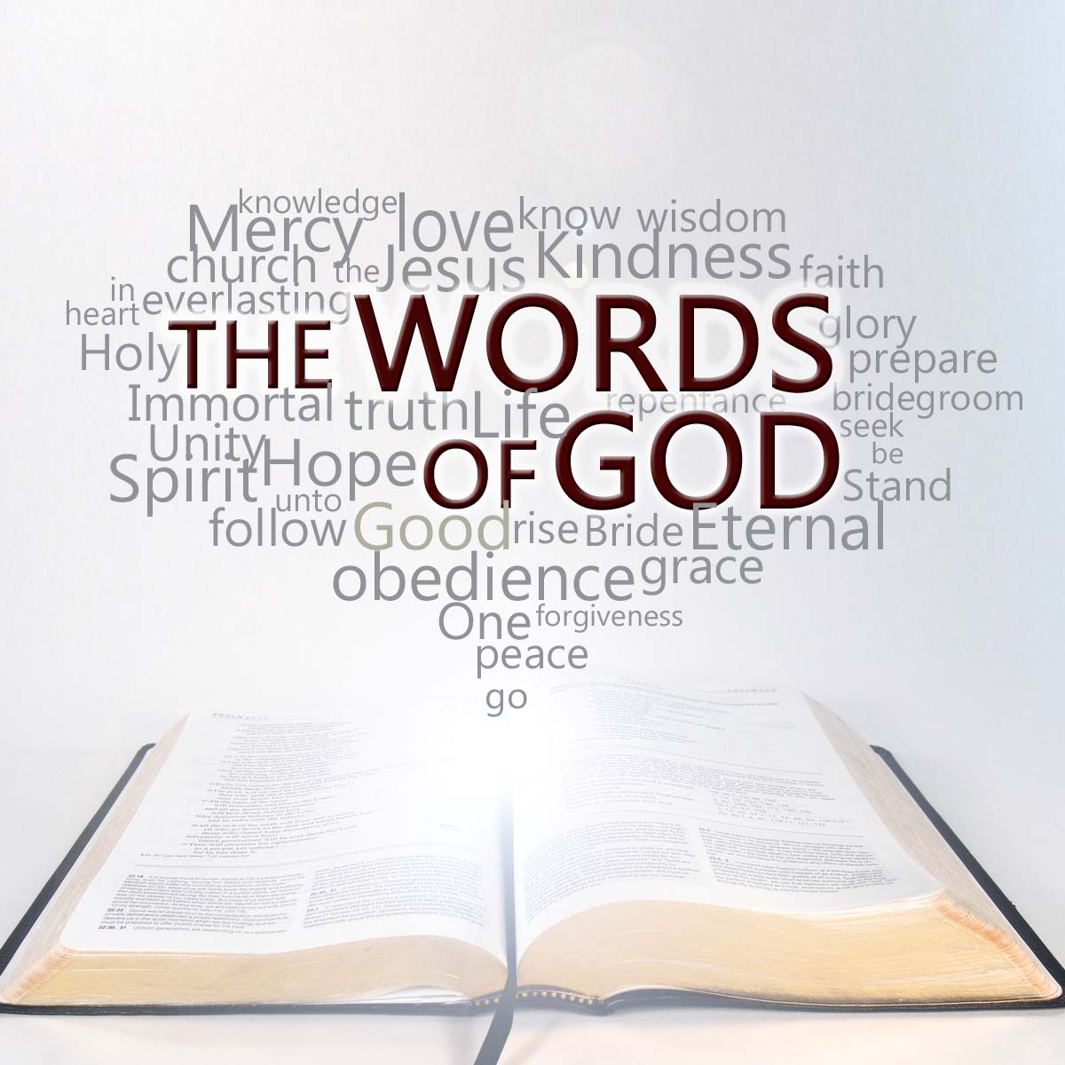
SERMON
Words of God
Elder Bob Hammel

AFFIRMATION OF FAITH The Apostle’s Creed (traditional)
I Believe in God the Father Almighty, Maker of heaven and earth, And in Jesus Christ his only Son our Lord; who was conceived by the Holy Ghost, born of the Virgin Mary, suffered under Pontius Pilate, was crucified, dead, and buried; he descended into hell; the third day he rose again from the dead; he ascended into heaven, and sitteth on the right hand of God the Father Almighty; from thence he shall come to judge the quick and the dead. I believe in the Holy Ghost; the holy catholic Church; the communion of saints; the forgiveness of sins; the resurrection of the body; and the life everlasting. Amen.

PRAYERS OF THE PEOPLE AND THE LORD’S PRAYER
Our Father who art in heaven, hallowed be thy name. Thy kingdom come, thy will be done, on earth as it is in heaven. Give us this day our daily bread; and forgive us our debts, as we forgive our debtors; and lead us not into temptation, but deliver us from evil. For thine is the kingdom and the power and the glory, forever. Amen.

CALL TO OFFERING Elder Bob Hammel

CHARGE AND BENEDICTION Elder Bob Hammel

POSTLUDE Crown Him with Many Crowns Benjamin Watkins, organ

UPC Prayer List - Email requests to: pastor.upcbloomington@gmail.com.
Evelyn Rose Shea Henry Troy Hill Judie Iverson Sue Lorimer & grandson Rob Lorimer Olivia McKenzie Ceci Schuman Alexander de Vos van Wael Nora vander Heijden
His Eyes Mission in Honduras led by the Colby’s
Nyaka AIDS Orphans Project in Uganda led by Jackson Kaguri
UPC’s elementary, junior & senior high, college and grad students in these difficult times
Medical professionals from coast to coast Monroe County’s law enforcement officers
Roachdale Presbyterian Church – Reverend David Bower, ecumenical pastor
Mary Lou Rhoades – in addition to prayer, encouragement and Thinking of You cards and letters would be appreciated. And visits too!
Mary Lou Rhoades
Bell Trace
800 N. Bell Trace Circle, #154; Bloomington, IN 47408

