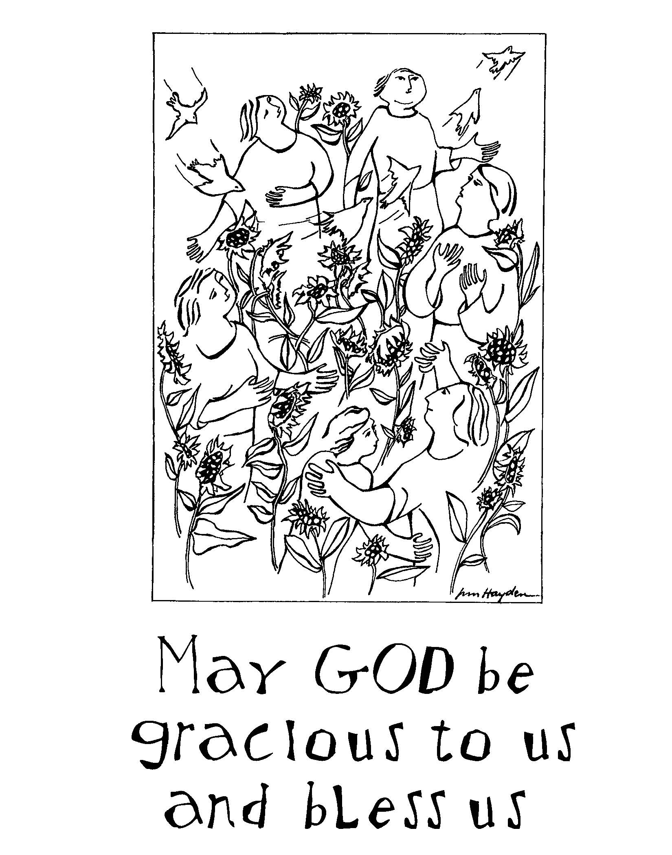

United Presbyterian Church
1701 E. Second Street
Bloomington, IN 47401

Sunday — July 10, 2022

Reverend Susan McGhee
Executive Presbyter of POV
Guest Minister

812-332-1850 www.upcbloomington.org
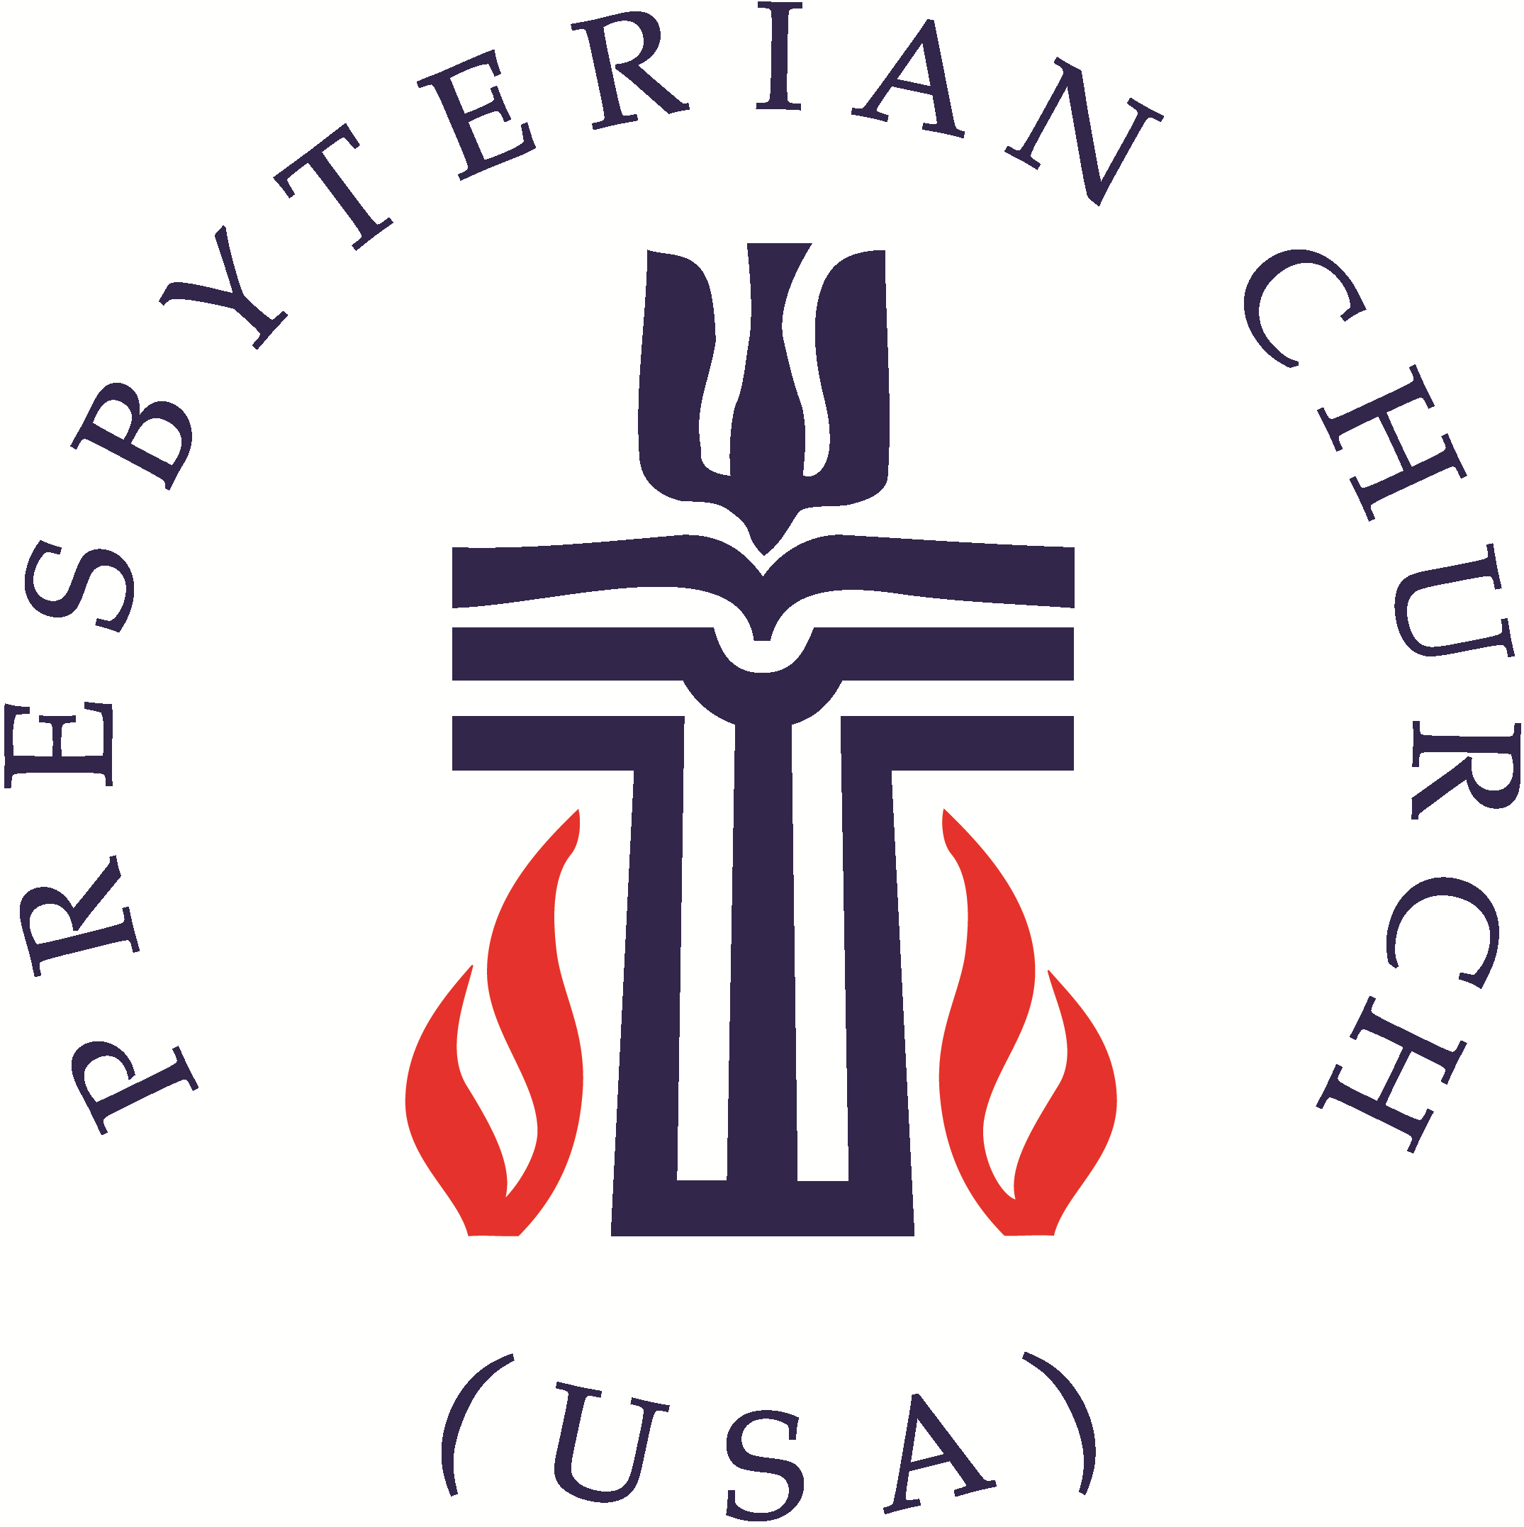
United Presbyterian Church Worship Guide
July 10, 2022 – Fifth Sunday after Pentecost

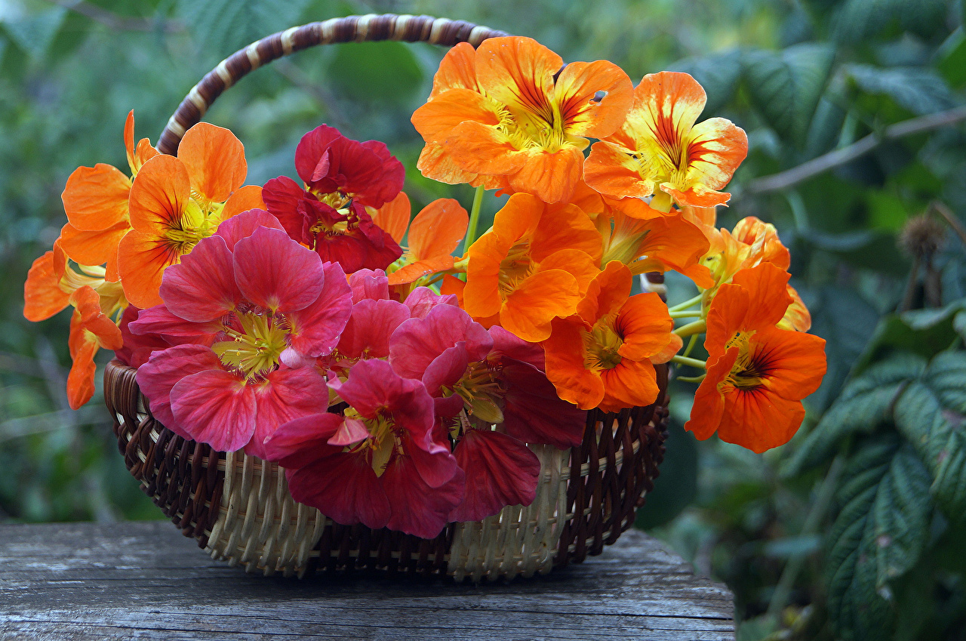
WELCOME AND ANNOUNCEMENTS Elder Allen Pease

Sanctuary Flowers are lovingly placed throughout July
by Jim Haverstock in celebration of the birthday of his beloved late wife Sue and in commemoration of their wedding anniversary.

PRELUDE Prelude and fugue in A-flat major from Well-Tempered Clavier Book 1 – J.S. Bach James LaVelle, piano

Call to Worship Elder Bob Hammel, liturgist
Liturgist: Let us sing to God who blesses us abundantly.
People: O God, give light to our eyes.
Liturgist: Trust in God's steadfast love; rejoice in God's salvation.
People: God meets us here and answers our soul's longings.
Liturgist: Let us worship God.
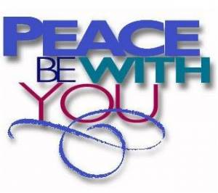
PASSING OF THE PEACE
Liturgist: The peace of Christ be with you.
People: And also with you.
Liturgist: Let us share the peace with one another.

*Opening Hymn #150, Come, Christians, Join to Sing

PRAYER OF CONFESSION (in unison with Liturgist)
Merciful God, we humble ourselves before you today to confess the ways in which we have failed. We have fallen short of your call to welcome all your children, to include enemies and even those different than we are. You have called us to give the cup of cold water to even the least, but we look the other way. You know our hesitations God. You know our fears and doubts and selfish ways. Forgive us and give us courage to serve you in all our actions pray. Amen.

WORDS OF ASSURANCE (Liturgist)
Hear the good news of the gospel! You are no longer strangers and aliens, but members together of the household of God, built upon the foundation of the prophets and apostles, with Christ Jesus himself as the cornerstone. In him the whole structure is joined together and grows into a holy temple in the Lord. Christ himself is our peace; in his flesh he has made us into one. Amen.
The New Testament Lesson Colossians 1:1-14 (pew Bible p896; large print p1812) – Liturgist
The Gospel Lesson Luke 10:25-37 (pew Bible p793; large print p1600) – Rev. Susan McGhee
Reverend: The word of the Lord
People: Thanks be to God
Sermon
Like a Good Neighbor
Reverend Susan McGhee

MUSIC MEDITATION Impromptu in A-flat Major, opus 90 no. 4 – Franz Schubert James LaVelle, piano

AFFIRMATION of FAITH – The Apostle’s Creed (traditional) led by Rev. McGhee
I Believe in God the Father Almighty, Maker of heaven and earth, And in Jesus Christ his only Son our Lord; who was conceived by the Holy Ghost, born of the Virgin Mary, suffered under Pontius Pilate, was crucified, dead, and buried; he descended into hell; the third day he rose again from the dead; he ascended into heaven, and sitteth on the right hand of God the Father Almighty; from thence he shall come to judge the quick and the dead. I believe in the Holy Ghost; the holy catholic Church; the communion of saints; the forgiveness of sins; the resurrection of the body; and the life everlasting. Amen.

PRAYERS OF THE PEOPLE AND THE LORD’S PRAYER Clerk & Elder Don Root
Our Father who art in heaven, hallowed be thy name. Thy kingdom come, thy will be done, on earth as it is in heaven. Give us this day our daily bread; and forgive us our debts, as we forgive our debtors; and lead us not into temptation, but deliver us from evil. For thine is the kingdom and the power and the glory, forever. Amen.

CALL TO OFFERING Clerk & Elder Don Root
*Closing Hymn #335, Though I May Speak

CHARGE AND BENEDICTION Reverend Susan McGhee

THE POSTLUDE Prelude no 15 in D-flat major – Frederic Chopin James LaVelle, piano

UPC Prayer List - Email requests to: upcbloomington@gmail.com.
Shea Henry Olivia McKenzie Betty Thacker Nora vander Heijden Cathy Junken
Rev. David Rosen John Swanson Berta Wenneker
His Eyes Mission led by Felipe & Valerie Colby in Honduras
Nyaka AIDS Orphan’s Project led by Jackson Kaguri in Uganda
UPC’s elementary, middle & senior high school students as well as college and grad school students as they prepare to return to school in August
Dale Presbyterian Church is the only Presbyterian Church in the county. We’re small in numbers but mighty in the service of our Lord and Savior Jesus Christ. We are active in the areas of mental health, ecology, working with our Hispanic/Latino/Latina neighbors and especially providing ministry and support in the areas of nutrition, housing, health, education and safety for the "least among us." Our ecumenical partnerships are strong as together we provide many of these services lacking in small town and rural communities. We are scripturally grounded, Holy Spirit inspired lovers of Jesus who believe in the promises of God and hope for the future. Our pastor who has served us for almost 22 years, Rev. Dr. Martha FrizLanger, is retiring in August. As we look hopefully for an amazingly faithful and grounded pastor, we covet your prayers.

Today’s Guest Artist
We’re delighted to have James LaVelle back with us today. A concert pianist, he’s a native of the Finger Lakes region of upstate New York. Initially drawn to the music of Beethoven he began studying classically in Ithaca before moving to the Midwest to earn a Bachelors degree from Eastern Michigan University followed by a Masters in piano performance from Jacobs School of Music at IU under the tutelage of the late Edmund Battersby. A converted Bloomingtonian, James resides here and maintains a private teaching studio as well as collaborating and presenting recitals.

Today’s Guest Minister
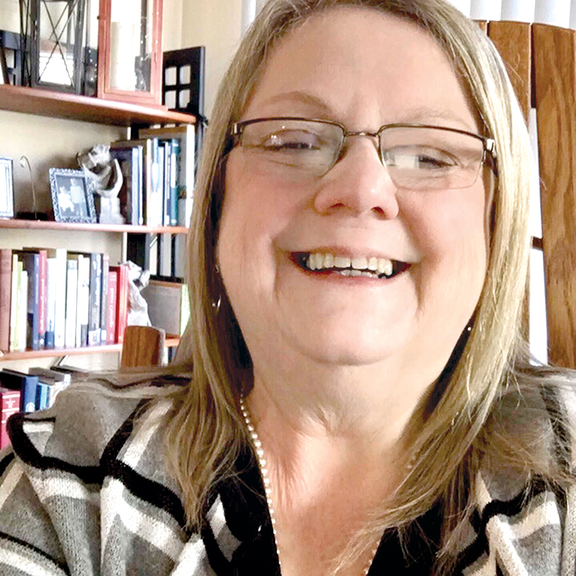
Reverend Susan McGhee has served as Executive Presbyter at the Presbytery of Ohio Valley since 2009. She’s a graduate of West Virginia Wesleyan College and Wesleyan Theological Seminary. We at UPC are unique among the churches of the POV in the fact that we get to see Susan often as the POV offices are on the lower level of our facility. Susan lives in Bloomington with her Calico kitties Kate and Allie. She welcomes prayers for family and friends, for all around the world who are struggling and for those engaged in education and action for racial justice.

Would you like to host a Fellowship Hour?

Now that COVID seems to be getting behind us and restrictions are being lifted more and more, we’ve been able to have some fun Fellowship Hours over the past six weeks.

Let’s keep the ball rolling! We need more folks to host a Fellowship Hour.

Hosting may be by yourself, families or friends may partner to host. Fare may be as simple as donuts or bagels with spreads or sweet rolls or cupcakes and, of course, coffee, tea and milk.
Simply sign up on the schedule posted on the North wall of Fellowship Hall for the Sunday you’d like to host.

