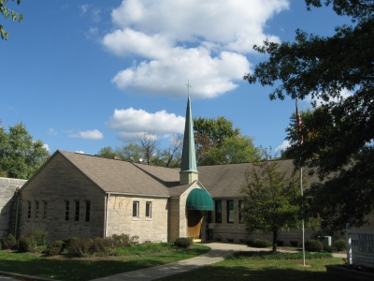

United Presbyterian Church
1701 E. Second Street
Bloomington, IN 47401

Sunday — July 24, 2022

Elder Don Root
UPC Clerk of Session
Guest Speaker

812-332-1850 www.upcbloomington.org
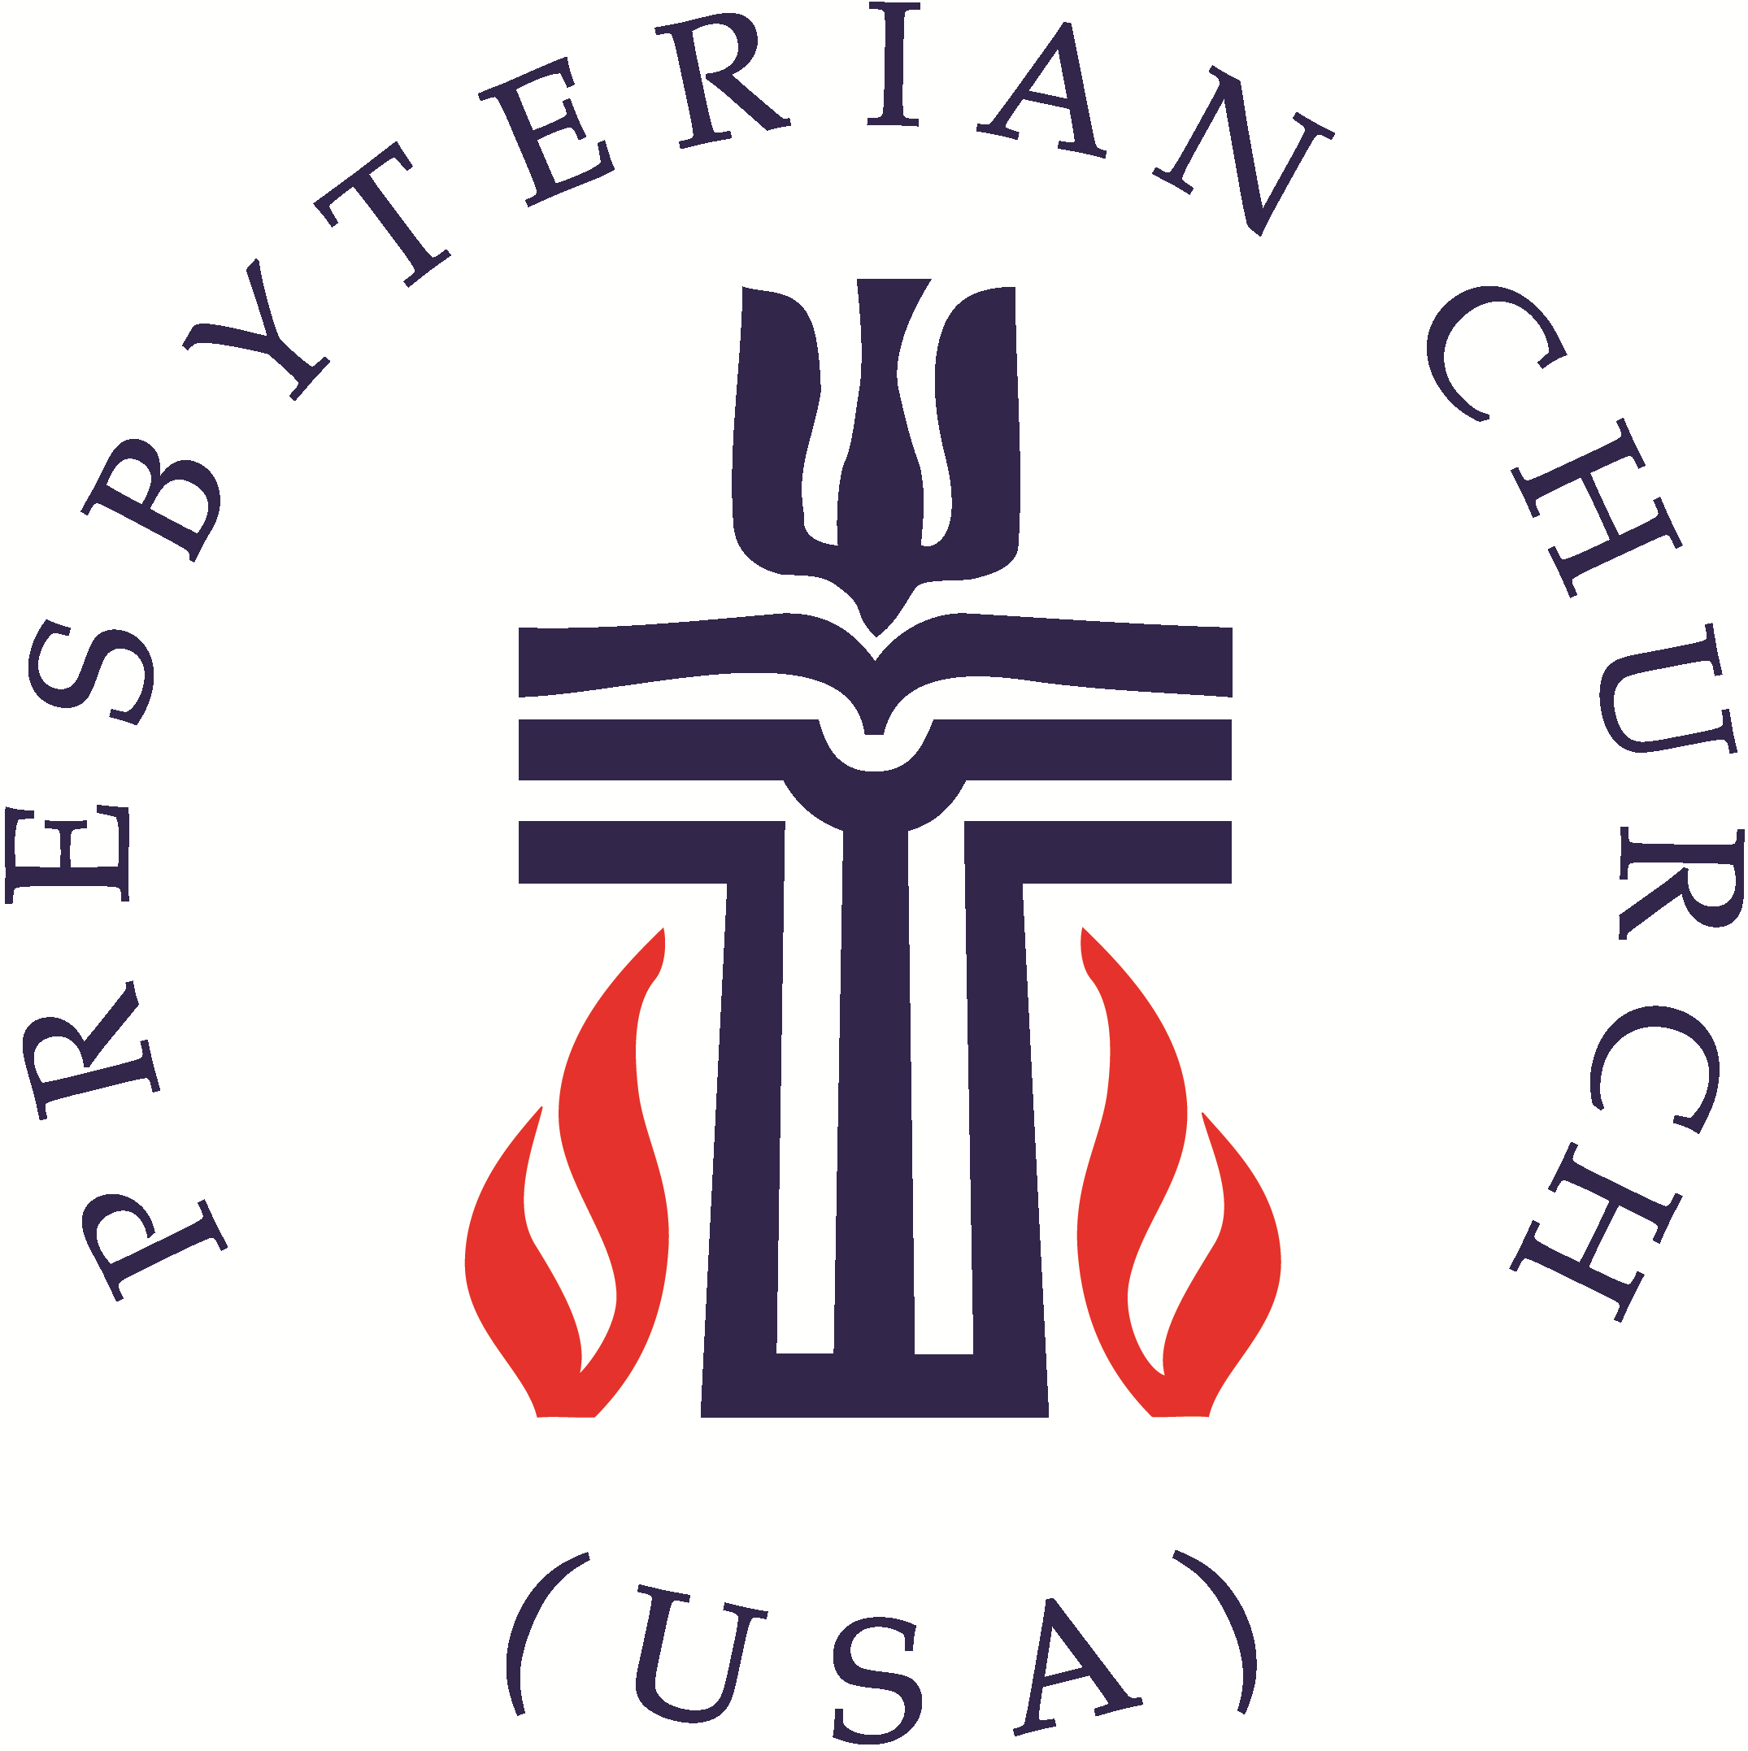
United Presbyterian Church Worship Guide
July 24, 2022 – Seventh Sunday after Pentecost

WELCOME AND ANNOUNCEMENTS Elder Allen Pease
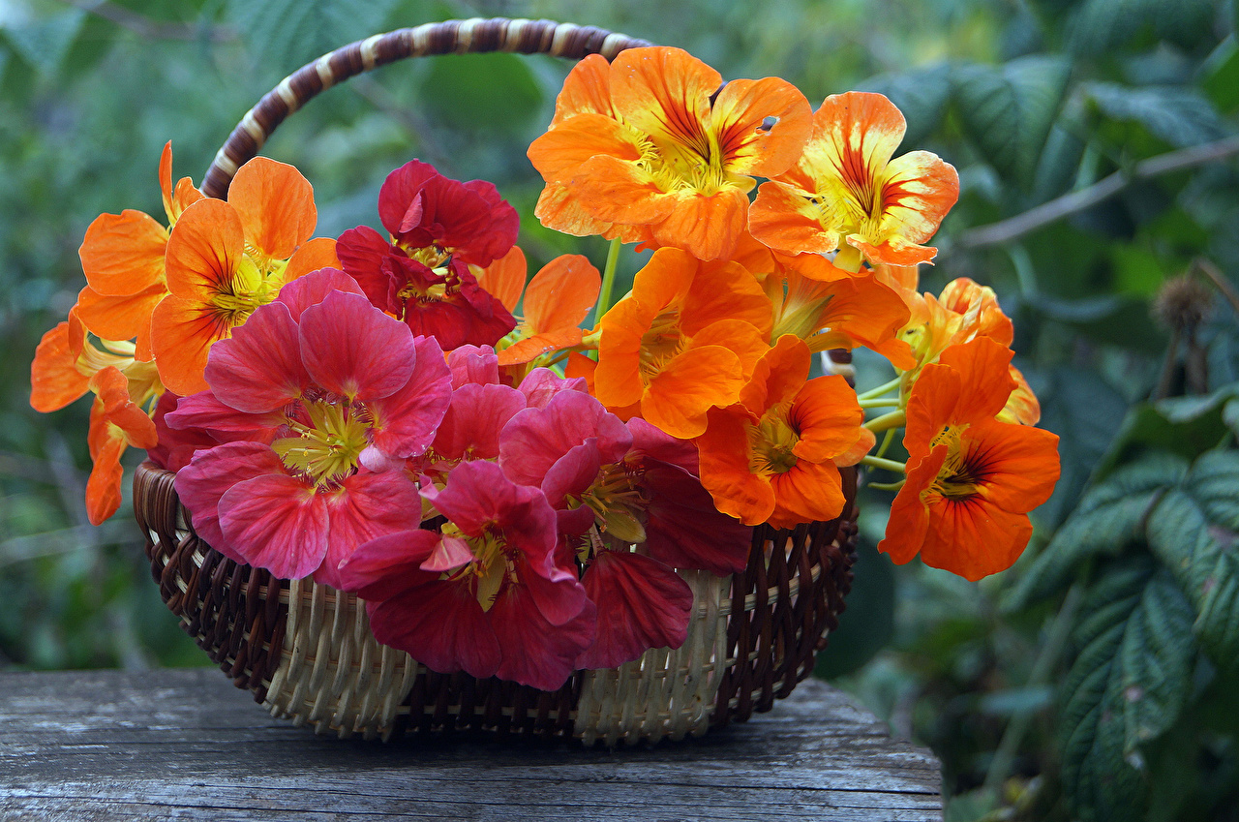
Sanctuary Flowers are lovingly placed throughout July
by Jim Haverstock in celebration of the birthday of his beloved late wife Sue and in commemoration of their wedding anniversary.

PRELUDE Julian Garvue, pianist

Call to Worship Deacon Vera Heitink, liturgist
Liturgist: Come all you that are weary and are carrying heavy burdens, and I will give you rest.
People: God is gentle and will give rest for our souls.
Liturgist: Let us find joy and gladness in our worship.
People: We will give God praise forever and ever.
Liturgist: Let us worship the God of Life.

PASSING OF THE PEACE
Liturgist: The peace of Christ be with you.
People: And also with you.
Liturgist: Let us share the peace with one another.

*Opening Hymn

PRAYER OF CONFESSION (in unison with Liturgist)
God of blessing, forgive us for our ingratitude for your creation, your creatures, and your people. We are all your children, yet we are neglectful of those who have less than we do. We find it too inconvenient to follow you. Forgive us for offering prayers for others and letting it go at that. Forgive us for honoring you with our words and actions today and then forgetting all about you when we get home. We pray for ourselves and each other in the name of Christ, our healer we pray. Amen.

WORDS OF ASSURANCE (Liturgist)
The mercy of the Lord is from everlasting to everlasting. I declare to you, in the name of Jesus Christ, you are forgiven. May the God of mercy, who forgives you all your sins, strengthen you in all goodness, and by the power of the Holy Spirit keep you in eternal life. Amen.

The Old Testament Lesson Genesis 15:1 - 6 (pew Bible p10; large print p20) – Liturgist
The New Testament Lesson Hebrews 11:8-16 (pew Bible p916; large print p1853) – Elder Root
Elder: The word of the Lord People: Thanks be to God
MUSIC MEDITATION Julian Garvue, pianist

Sermon
The Patience of Faith
Elder Don Root, Clerk of Session

AFFIRMATION of FAITH – The Apostle’s Creed (traditional) led by Elder Root
I Believe in God the Father Almighty, Maker of heaven and earth, And in Jesus Christ his only Son our Lord; who was conceived by the Holy Ghost, born of the Virgin Mary, suffered under Pontius Pilate, was crucified, dead, and buried; he descended into hell; the third day he rose again from the dead; he ascended into heaven, and sitteth on the right hand of God the Father Almighty; from thence he shall come to judge the quick and the dead. I believe in the Holy Ghost; the holy catholic Church; the communion of saints; the forgiveness of sins; the resurrection of the body; and the life everlasting. Amen.

PRAYERS OF THE PEOPLE and THE LORD’S PRAYER Elder Don Root
Our Father who art in heaven, hallowed be thy name. Thy kingdom come, thy will be done, on earth as it is in heaven. Give us this day our daily bread; and forgive us our debts, as we forgive our debtors; and lead us not into temptation, but deliver us from evil. For thine is the kingdom and the power and the glory, forever. Amen.

CALL TO OFFERING

*Closing Hymn

CHARGE AND BENEDICTION Elder Don Root

THE POSTLUDE Julian Garvue, pianist
*Stand if you are able
UPC Prayer List - Email requests to: upcbloomington@gmail.com.
Shea Henry Olivia McKenzie Betty Thacker Nora vander Heijden Cathy Junken
Rev. David Rosen Berta Wenneker
Rev. Napoli, Sarah and Johnny as they begin their transition
The UPC Session Board and Deacons as they guide us through our transition
His Eyes Mission led by Felipe & Valerie Colby in Honduras
Nyaka AIDS Orphan’s Project led by Jackson Kaguri in Uganda
The staff and clients of Monroe County United Ministries
Our Police, Sheriffs and other first responders throughout Monroe County
UPC’s medical professionals as well as those throughout the county and state
UPC’s elementary, middle & senior high school students as well as college and grad school students as they prepare to return to school in August (continued➔)
Eastminster Presbyterian Church (EPC) was founded in 1999, following a merger of the former Washington Avenue Presbyterian Church and the former Eastminster Presbyterian Church. We are located close to bustling Green River Road and the University of Evansville. Our mission statement is “Hearts, Hands, Heads for Christ in Service and Celebration.” We are 200 members strong and pride ourselves on our welcoming, friendly nature. EPC is, in every sense, a true family! We’re joyful for this, as well as for our amazing church staff. Our secretary, Mary Fulkerson, keeps everything running smoothly. Our youth program is strong, led by Youth Director/Pastoral Assistant Trey Fulkerson. His creativity and ability to truly connect with the youth has made this program flourish. We have a music department and choir, led by a talented music director Alanna Keenan and organist Rachel Luttrull. We’ve had a Christianity and the Arts program which allowed us to incorporate many performances from all artistic genres into our worship and special events. Christian Education is important to us, and that is reflected in our Sunday School for both children and adults. We also offer a wide variety of small group activities from meals to Saturday outings. We’d appreciate prayer for a bright and productive future under the leadership of the Rev. Ryan Bradney.

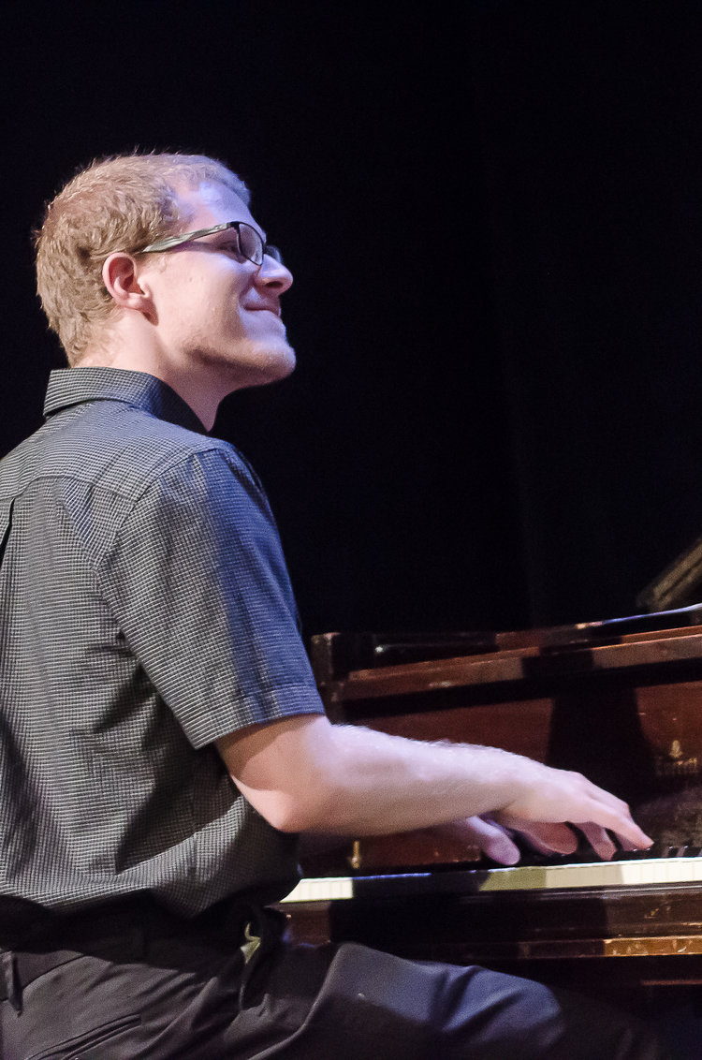
Today’s Guest Artist: Julian Garvue is a pianist from Seattle. Having recently earned his Master of Music from IU in May, Julian is excited to begin a Performer’s Diploma at IU in the fall. He’s been retained as rehearsal pianist for IU Opera Theater’s autumn production of Mozart’s Don Giovanni. Prior to his time at IU, Julian spent three years in Brooklyn, NY freelancing as a jazz pianist. He received his Undergraduate degrees in Jazz Piano and Music Theory from the Eastman School of Music in Rochester, NY, where he also served as Music Director for the Summerville Presbyterian Church. We are pleased to announce that Julian will be back with us again next Sunday.

Would you like to host a Fellowship Hour?

Now that COVID seems to be getting behind us and restrictions are being lifted more and more, we've been able to have some fun Fellowship Hours over the past seven weeks.

Let's keep the ball rolling! Host a Fellowship Hour.

Hosting may be by yourself, families or friends may partner to host. Fare may be as simple as donuts or bagels with spreads or sweet rolls or cupcakes and, of course, coffee, tea and milk.
Simply sign up on the schedule posted on the North wall of Fellowship Hall and pick the Sunday you'd like to host.

